

**Nurse Hiring System Project Report**

**Assignment 1-2 – Software Requirement Specification**

**Team 1 – SE1435 – SWR301**

– Bac Kan, 27 June 2021 –

Table of Contents

I. Project Report 3

1. Status Report 3

2. Team Involvements 3

3. Issues/Suggestions 3

II. Project Introduction 3

1. Overview 3

1.1 Project Information 3

1.2 Project Team 3

III. Functional Requirement 4

1. System Overview 4

1.1. Screen Flow 4

1.2. List Functional Required 5

2. Security 5

2.1. Authorization 5

2.2 <<Non – Screen Function>> 5

2.3 <<ERD – Entity Diagram>> 5

3. Functional Overview 5

3.1. Description 5

3.2. Prioritization 5

4. Non-Functional Requirements 6

4.1 Quality Attributes <Re-Write by Planguage> 6

5. Swinlane Diagram 6

3.1 Quality Attributes <Re-Write by Planguage> 6

# Project Report

## 1. Status Report

|  |  |  |  |
| --- | --- | --- | --- |
| **#** | **Work Item** | **Status** | **Notes (Work Item in Details)** |
| 1 |  | Pending |  |
| 2 |  | In Progress |  |
| 3 |  | Completed |  |

## 2. Team Involvements

|  |  |  |  |
| --- | --- | --- | --- |
| **#** | **Task** | **Member** | **Notes (Task Details, etc.)** |
| 1 | Front – End Develop | HaiLD |  |
| 2 | Back – End Develop | PhuongNL, ChienDC |  |
| 3 | Database Design, Function Design | DatHM,  PhuongNL |  |
| 4 | Business Analysts | TrungNH |  |
| 5 | Test, Debug Website | ChienDC |  |

## 3. Issues/Suggestions

|  |  |  |  |
| --- | --- | --- | --- |
| **#** | **Issue** | **Status** | **Notes (Solution, Suggestion, etc.)** |
| 1 |  |  |  |

# Project Introduction

## 1. Overview

### 1.1 Project Information

* Project name: Nurse Hiring System
* Project code: NHSK14
* Group name: SWR301-SE1435-T1
* Software type: Health Care HyFRid Application

### 1.2 Project Team

#### a. Supervisor

|  |  |  |  |
| --- | --- | --- | --- |
| **Full Name** | **Email** | **Phone Number** | **Title** |
| Pham Duc Thang | thangpd@fe.edu.vn |  | Lecturer |

#### b. Team Members

|  |  |  |  |
| --- | --- | --- | --- |
| **Full Name** | **Email** | **Mobile** | **Role** |
| Duong Cong Chien | chiendche141237@fpt.edu.vn |  | Leader |
| Luc Duong Hai | haildhe141223@fpt.edu.vn |  | Member |
| Nguyen Long Phuong | phuongnlhe141219@fpt.edu.vn |  | Member |
| Ha Manh Dat | dathmhe141249@fpt.edu.vn |  | Member |
| Nguyen Huu Trung | trungnhhe141239@fpt.edu.vn |  | Vice Leader |

# III. Functional Requirement

## 1. System Overview

### 1.1. Screen Flow

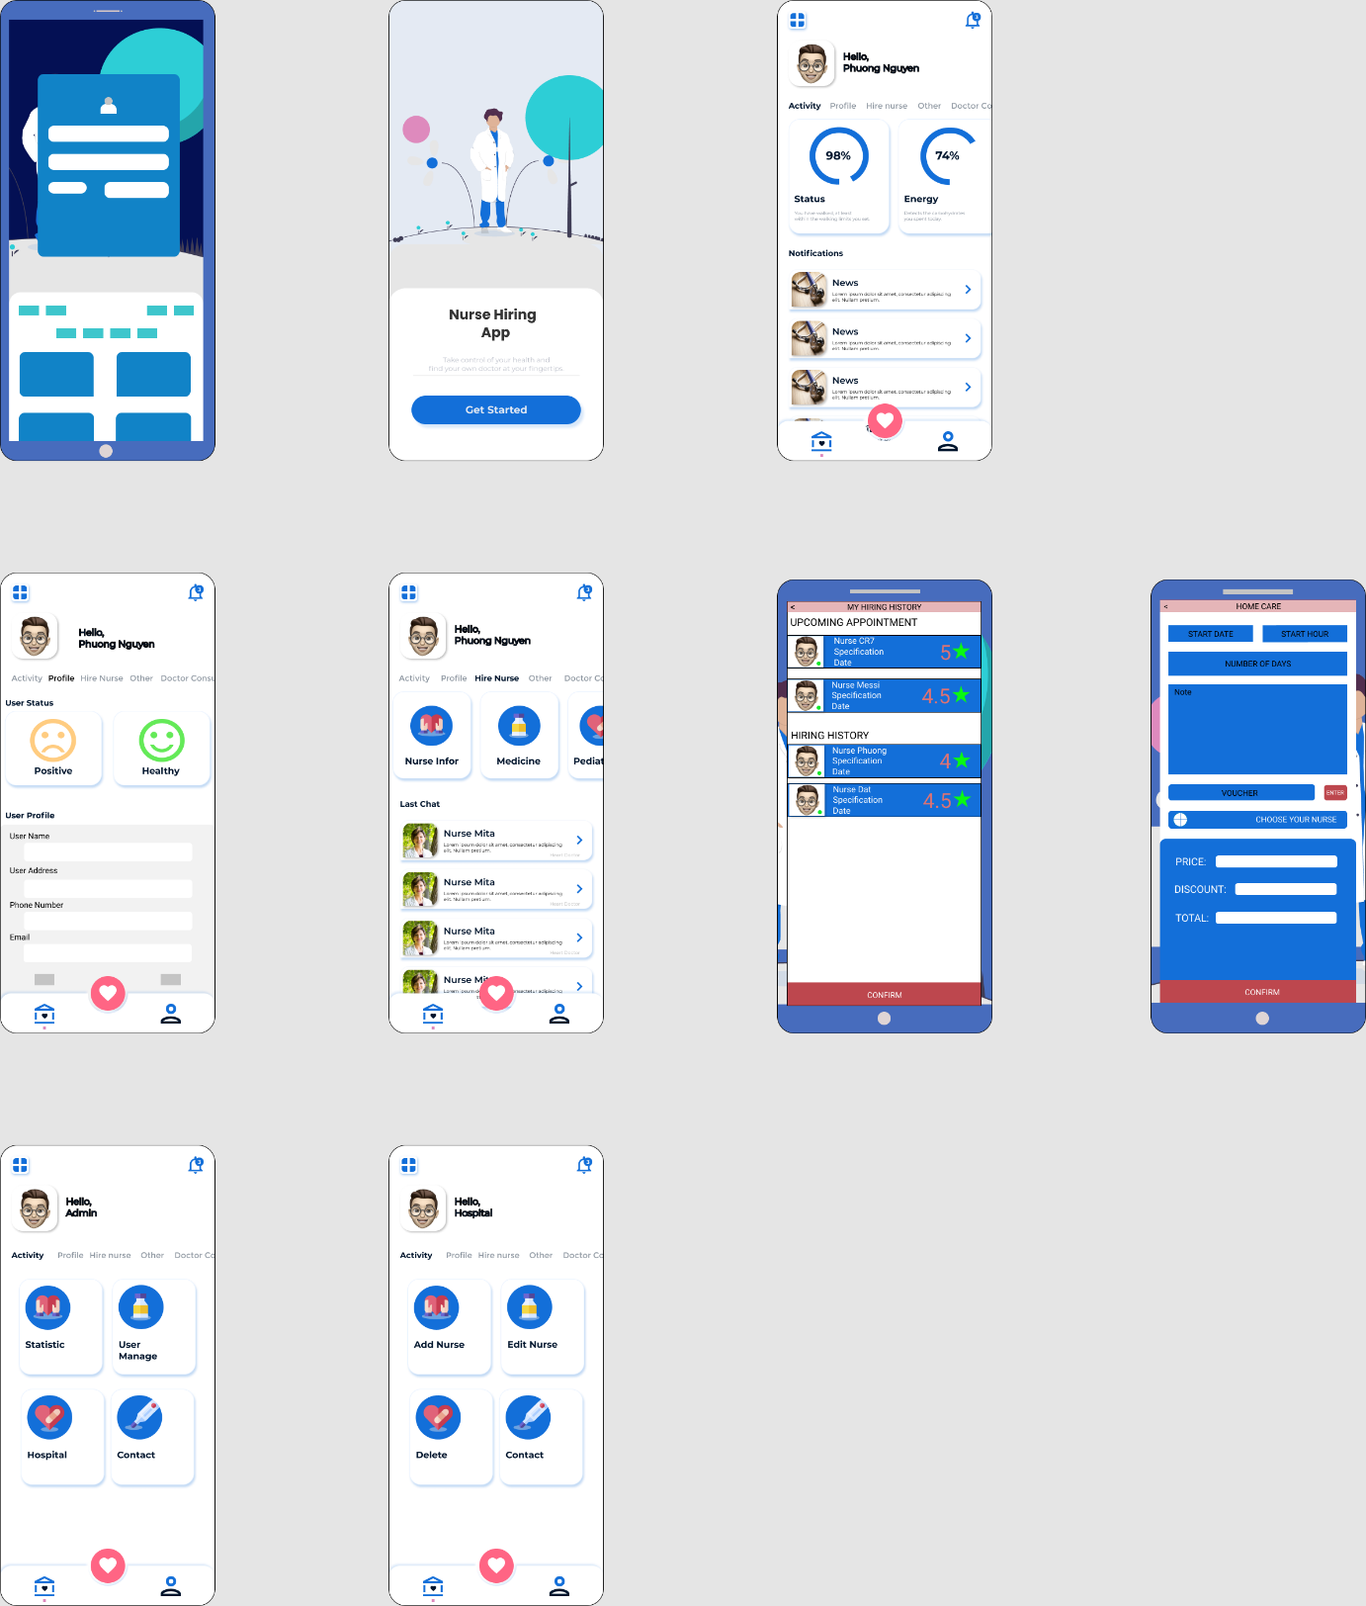

**Fig. 1. Screen Flow**

### 1.2. List Functional Required

|  |  |
| --- | --- |
| ID | Functional Requirement |
| FR-01 | Log in to the Nurse Hiring System with normal account, Google, Facebook’s Account. |
| FR-02 | Log out to the Nurse Hiring System |
| FR-03 | User sign up a normal account or using Google, Facebook. |
| FR-04 | Update their personal profile |
| FR-05 | View personal profile.  1. User view nurse, nurse manager profile.  2. Admin view all infor profile  3. Moderator view nurse, user, nurse manager profile |
| FR-06 | User create nurse orders |
| FR-07 | User delete nurse orders after hired nurses. |
| FR-08 | User can view history nurse order |
| FR-09 | User can view nurse manager infor like Hospital, Healcare center information |
| FR-10 | User search name nurse to find what nurse they really want |
| FR-11 | User paid money for system application |
| FR-12 | Notifications was show when all object person active their activities depends on their roles |
| FR-13 | Nurse manager view nurse order was created by user |
| BE-14 | 1. Edit Nurse  2. Delete Nurse |

## 2. Security

### 2.1. Authorization

#### a. User Authorization

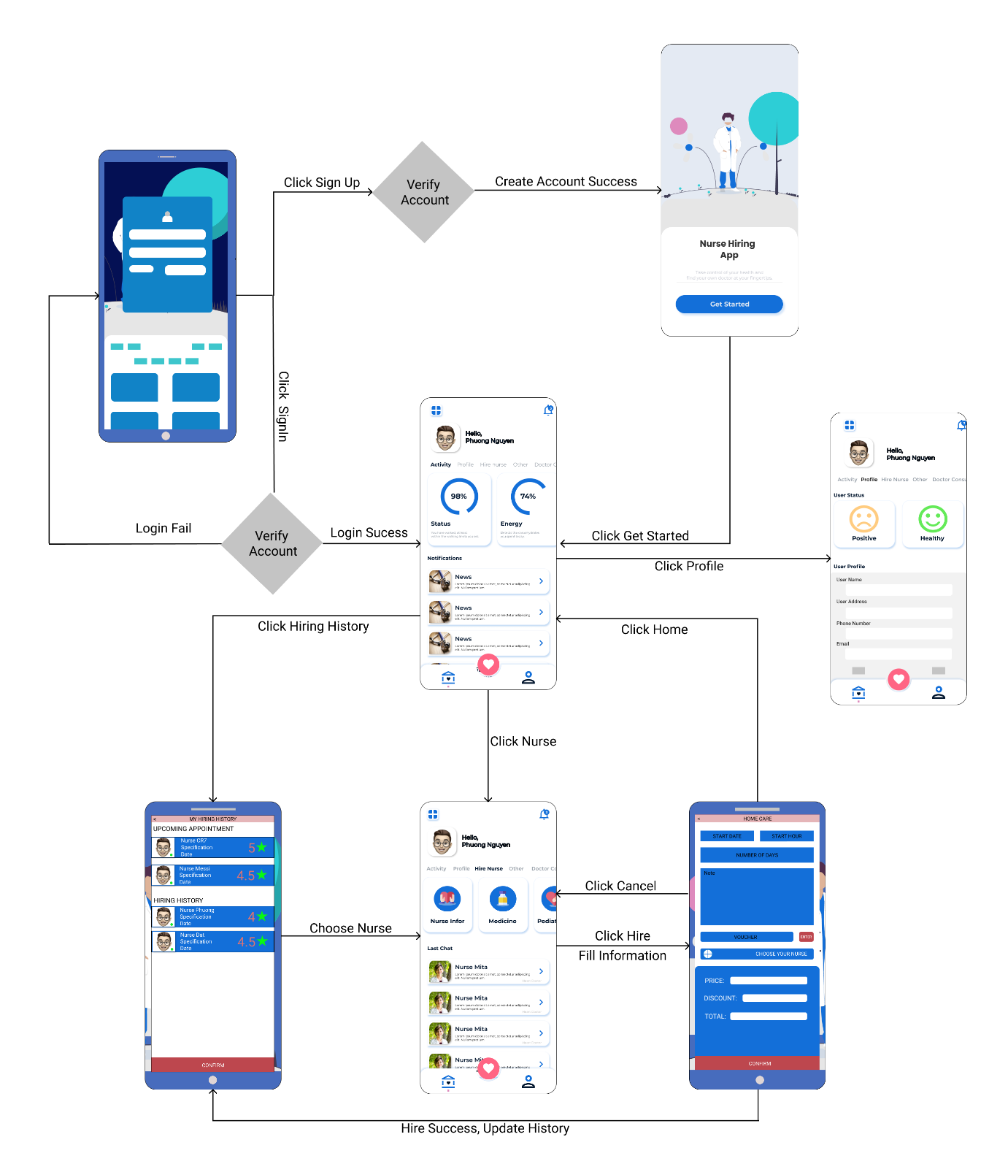

**Fig. 2. User Authorization Screen**

#### b. Nurse Authorization

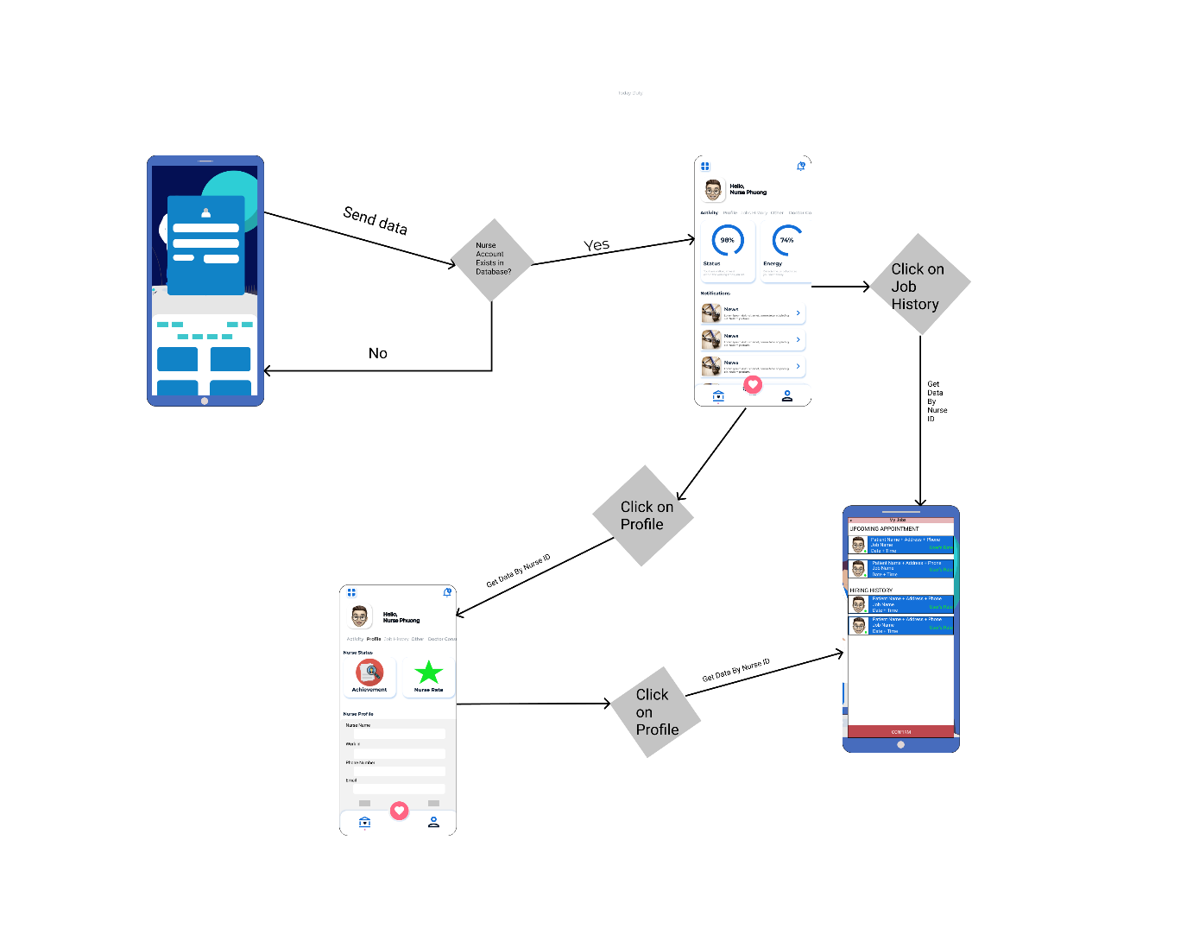

**Fig. 3. Nurse Authorization Screen**

#### c. Nurse Manager Authorization

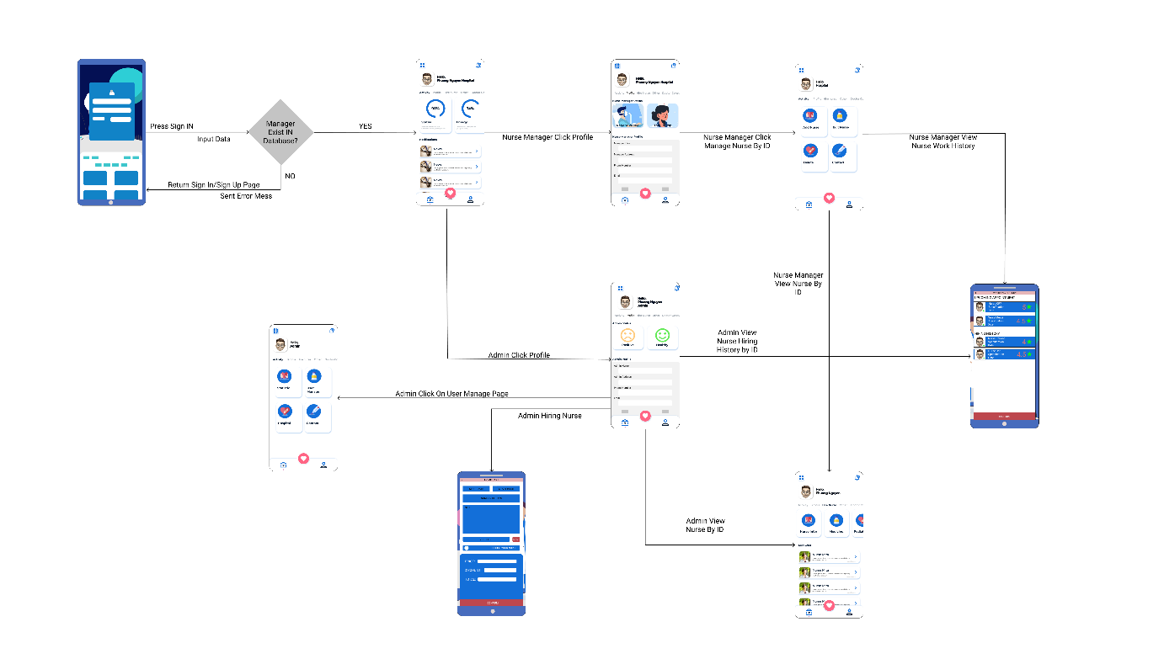

**Fig. 4. Manager Authorization Screen**

### 2.2 <<Non – Screen Function>>

|  |  |
| --- | --- |
| ID | Non – Screen Function |
| NSF – 01 | Calculate the time the user uses the application. |
| NSF – 02 | Calculate the time the nurse worked. |
| NSF – 03 | Automatically cancel orders in 5 minutes if user does not reconfirm orders. |
| NSF – 04 | Manage order in Database (CRUD). |
| NSF – 05 | Manage user info in Database (CRUD). |
| NSF – 06 | Manage nurse info in Database (CRUD). |
| NSF – 07 | Store user’s order to history of each user. |
| NSF – 08 | Calculate the salary of the nurse. |
| NSF – 09 | Calculate the money user pay. |

### 2.3 <<ERD – Entity Diagram>>

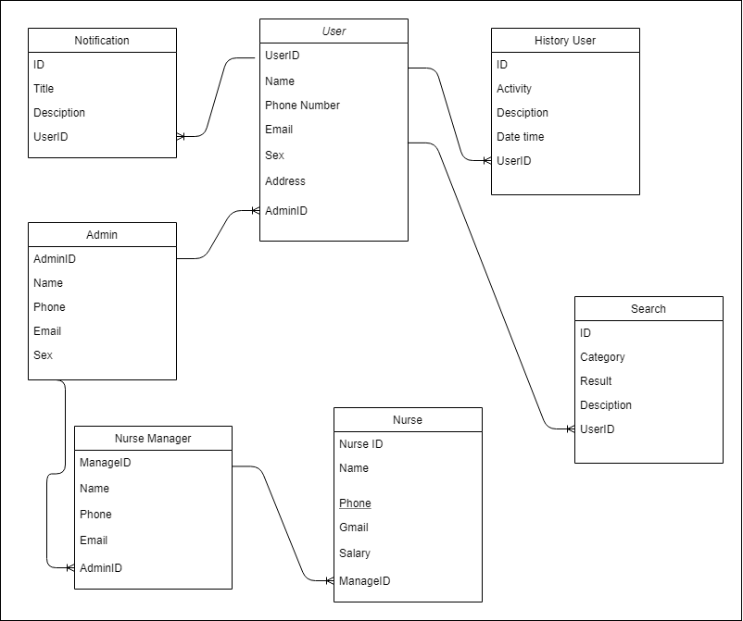

**Fig. 5. Entity Diagram**

## 3. Functional Overview

### 3.1. Description

#### 3.1.1. <<Sign IN Function>> - Luc Duong Hai – HE141223

|  |  |
| --- | --- |
| Function Name | Function Description |
| SIGN IN | I. User Choose the method to Sign IN  1. Sign IN using normal account. 2. Sign IN using google account. 3. Sign IN using facebook account.  II. When user choose method SIGN IN WITH Google ACCOUNT  1. System sent request to get code and access token after that get user google’s account infor by using Google API console. 2. Check email user google account’s exist in database or not. If email exist allow user login and goto Home Layel. If not sent user back to Login Layel and show error messages.  III. When user choose method SIGN IN WITH Facebook ACCOUNT  1. System sent request to get user facebook’s account. After that, user login with facebook, allow system get infor and return access token. 2. System using access token to get user infors. 3. After got user facebook infor and other infor, system check user infor in database. If this infor valid to database infor then system allow user login, if not sent user back to SignIN layel and show error messages.  IV. When user choose method SIGN IN WITH System Account  1. User sign in using their own account sign up before. After that system get date from form. Then system check validate account, email, passwords. If input data is validated. System check user infor in Database. 2. If user infor existed, system return user to Home Layel show messages “Login Success”, if not system bring user back Login Layel and Show Messages.  V. Following Step  1. User goto SignIN Layel 2. User choose method to login 3. User enter user’s required infor (IF NEEDED)  VI. Considerable Factors:  * N/A |

#### 3.1.2. <<Sign UP Function>> - Luc Duong Hai – HE141223

|  |  |
| --- | --- |
| Function Name | Function Description |
| SIGN UP | I. User Choose Method to Sign UP  1. Sign UP normal account 2. Sign UP with facbook account 3. Sign UP with google account  II. When user choose method Sign UP normal account  1. User sent request Sign UP to system. After user input all require data like email, passwords, repasswords and check captcha. After that, system will check data, if data user input valid and captcha got checked. 2. System will send code to mail user input. If the user enters true code, the system allows saving user info to the database and session, after that bring to Start Layel to finish important infor. When a user fills in all-important infor. The system will send the user to Home Layel.  III. When user choose method Sign UP with google  1. User sent request Sign UP to system. Then the system sent a request to google to get access token and code using clientID and Secret Key from OAuth API. 2. After that system will send the user to the Start Layel to finish important info and sent mail, force the user to actives account. When user finishes all the following steps, the system saves user infor to the database and session, bring user to Home Layel.  IV. When user choose method Sign IN with facebook  1. User sent request Sign UP to system. Then the system sent a request to facebook to get access token and code using facebook app dev. 2. After got user access token, the system will use the access token to get user information. When the system checks user valid infor, the system brings user to the Start Layel. Let’s user enter important information and send mail force user to actives account. After finish all steps, the system brings user to Home Layel.  V. Following Step  1. User goto SignUP Layel 2. User choose method to SignUP 3. User enter user’s required infor (IF NEEDED) |

#### 3.1.3. <<Create order nurse>> - Nguyen Long Phuong – HE141219

|  |  |
| --- | --- |
| Function Name | Function Description |
| CREATE ORDER NURSE | 1. When user want to hire nurse, user need to choose nurse and create order nurse, in this order, user must fill enough information:   Name: Phuong Nguyen  Phone number: 0929008000  Address: Ha Noi  Patient Status: Weaked  Card number: 010202039405966   1. After click hire, if all information are correct the order will be create and save into history, else warning user check information again. |

#### 3.1.4. <<Delete order nurse>> - Nguyen Long Phuong – HE141219

|  |  |
| --- | --- |
| Function Name | Function Description |
| DELETE ORDER NURSE | 1. After create order to hire nurse, user have 3 minutes to decide want to cancel order. After 3 minutes, the order can not be cancel 2. User click on History Hiring 3. User click Cancel order 4. A confirm dialog will display for user choose YES/NO 5. Click YES to confirm Cancel Order 6. Click NO to continue hire. |

#### 3.1.5. <<View history nurse order>> - Duong Cong Chien – HE141245

|  |  |
| --- | --- |
| Function Name | Function Description |
| VIEW HISTORY NURSE ORDER | 1. After the order was created, system stored it into the database, and can view again by the list history order of nurse in history page, system allow user can see it and the evaluate the nurse was received 2. User click on History Hiring 3. User can see the evaluate 4. User can hire nurse or ignore 5. A confirm dialog will display for user choose YES/NO 6. Click YES to confirm hire 7. Click NO to confirm cancel Order. |

#### 3.1.6. <<View user manager info (like hospital, healcare center info)>> - Duong Cong Chien – HE141245

|  |  |
| --- | --- |
| Function Name | Function Description |
| VIEW USER MANAGER INFO | 1. User can view nurse manager infor like Hospital, Healcare center information 2. User can see all the nurses of each hospital, healcare center 3. User can see all evaluate of nurse 4. User can choose and see all information of each nurse 5. User can hire nurse in list nurses of manager’s list. 6. User can hire nurse or ignore 7. A confirm dialog will display for user choose YES/NO 8. Click YES to confirm hire 9. Click NO to confirm cancel Order. |
| Function Name | Function Description |
| VIEW HISTORY NURSE ORDER | 1. After the order was created, system stored it into the database, and can view again by the list history order of nurse in history page, system allow user can see it and the evaluate the nurse was received 2. User click on History Hiring 3. User can see the evaluate 4. User can hire nurse or ignore 5. A confirm dialog will display for user choose YES/NO 6. Click YES to confirm hire 7. Click NO to confirm cancel Order. |

#### 3.1.7. <<User search nurse>> - Nguyen Huu Trung – HE141239

|  |  |
| --- | --- |
| Function Name | Function Description |
| SEARCH NURSE | 1. User search name nurse to find what nurse they really want, user can search by name of nurse, name of nurse’s manager, price will pay for this nurse 2. User input the search info in textbox, choose the dropdown value search and click on button search 3. User can see the list of nurses in the screen in by real time 4. User can see the basic info of each nurse 5. User can click into the name or image to go to the nurse detail page |

#### 3.1.8. << User paid money for system application >> - Nguyen Huu Trung – HE141239

|  |  |
| --- | --- |
| Function Name | Function Description |
| SEARCH NURSE | 1. After create order for user, system require user pay money for system before accept hiring nurse and finish this order 2. User go to the payment page and handling payment 3. User select the payment method 4. User accept pay money for nurse or not 5. A confirm dialog will display for user choose YES/NO 6. Click YES to confirm payment 7. Click NO to cancel payment. |

#### 3.1.9. << User Manager >> - Ha Manh Dat – HE141249

|  |  |
| --- | --- |
| Function Name | Function Description |
| User Manager | 1. User login and must have admin roles 2. User can go to Management page 3. In our website admin can edit/remove/add/ban User 4. User that will be edited/added can not be similar to others 5. If the admin adds user, the system will check exists account and similar account. If user do not exists add new ones. Like add, edit functions let admin edit user which was existed in the database. |

#### 3.1.10. << Nurse Manager >> - Ha Manh Dat – HE141249

|  |  |
| --- | --- |
| Function Name | Function Description |
| User Manager | 1. The Hospital can add/edit/ban Nurse 2. Hospital can go to Nurse Management page 3. In our website Hospital admin can edit/remove/add/ban Nurse 4. Nurse that will be edited/added can not be similar to others 5. Hospital Admin can also arrange works for Nurse and change work arrangement. 6. If the Hospital admin adds nurse, the system will check exists account and similar account. If user do not exists add new ones. Like add function, edit functions let admin edit user which was existed in the database. |

### 3.2. Electronic Prototype

#### 3.2.1. SignIN Prototype - HaiLD

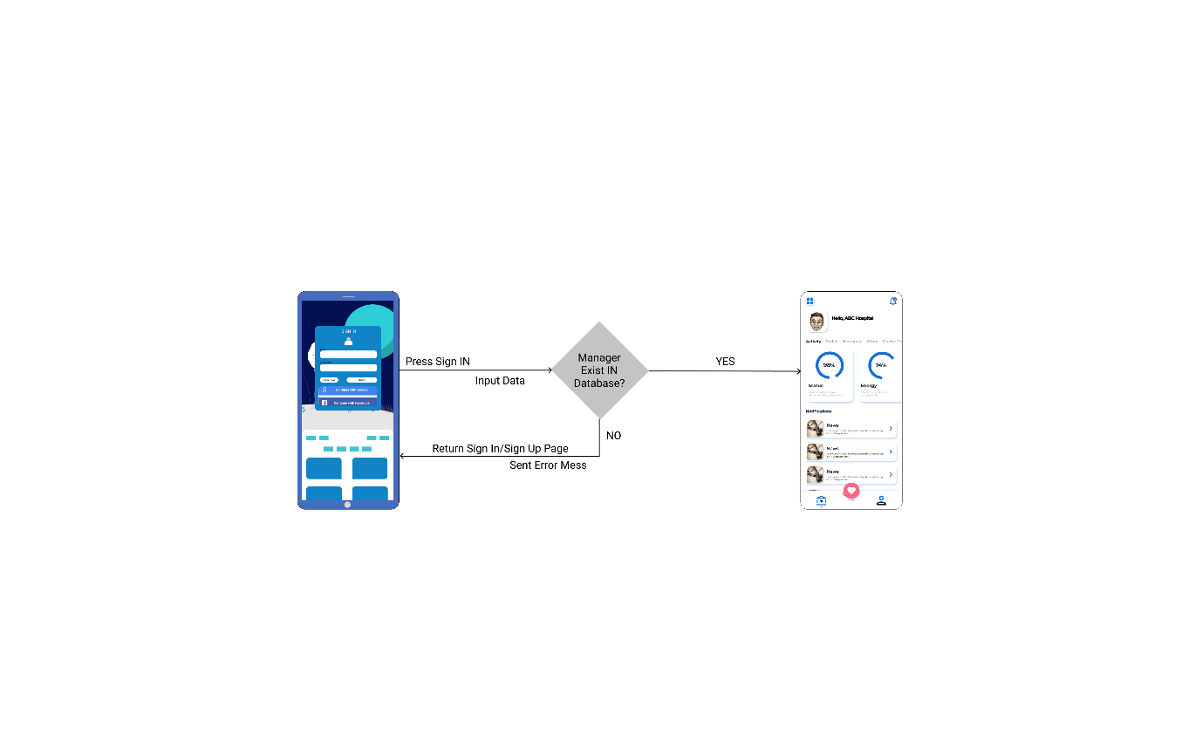

#### 3.2.2. SignUP Prototype - HaiLD

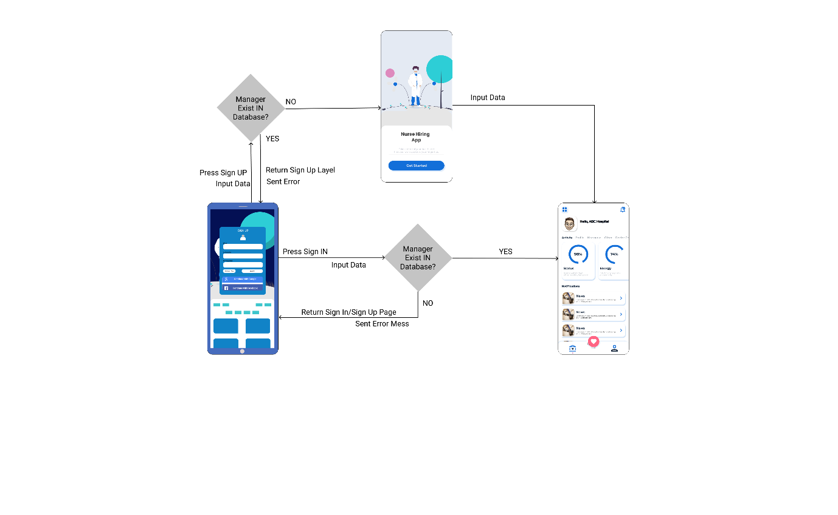

#### 3.2.3. Order Prototype - PhuongNL

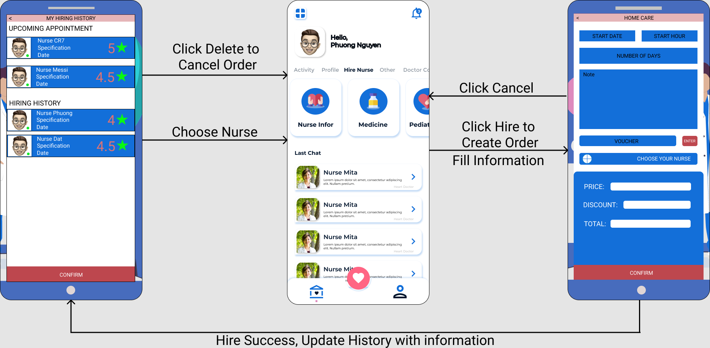

#### 3.2.4. Delete Order Prototype - PhuongNL



#### 3.2.5. Profile Admin Prototype - DatHM

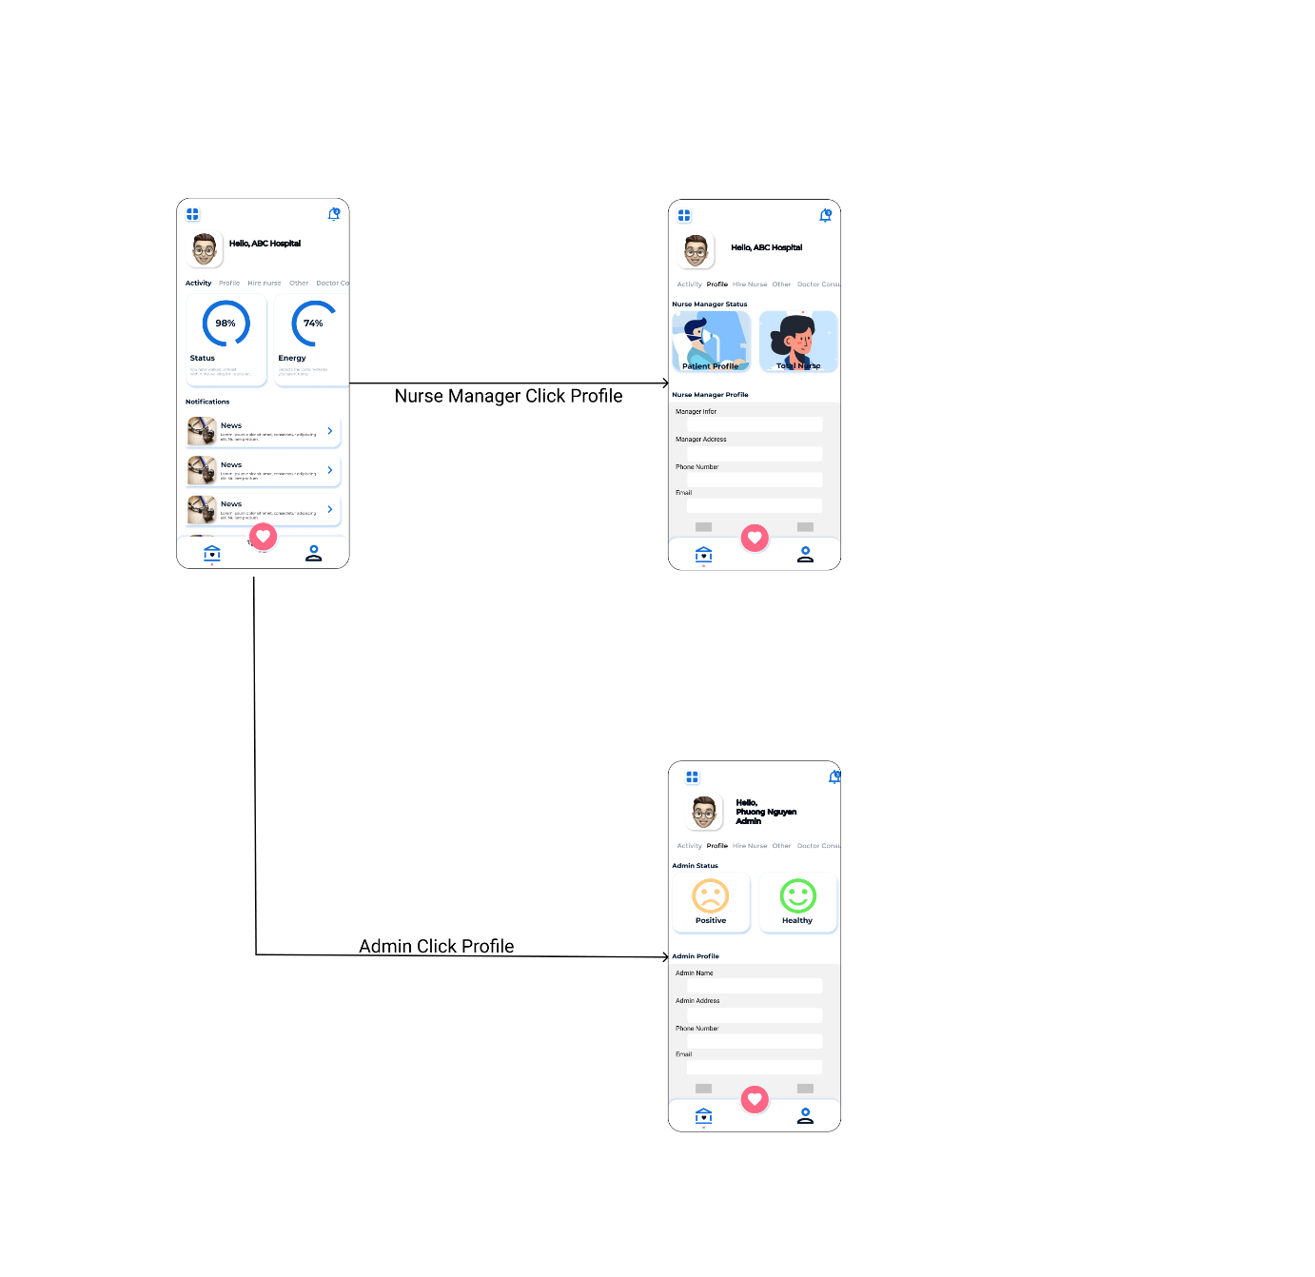

#### 3.2.6. Profile User Prototype - DatHM

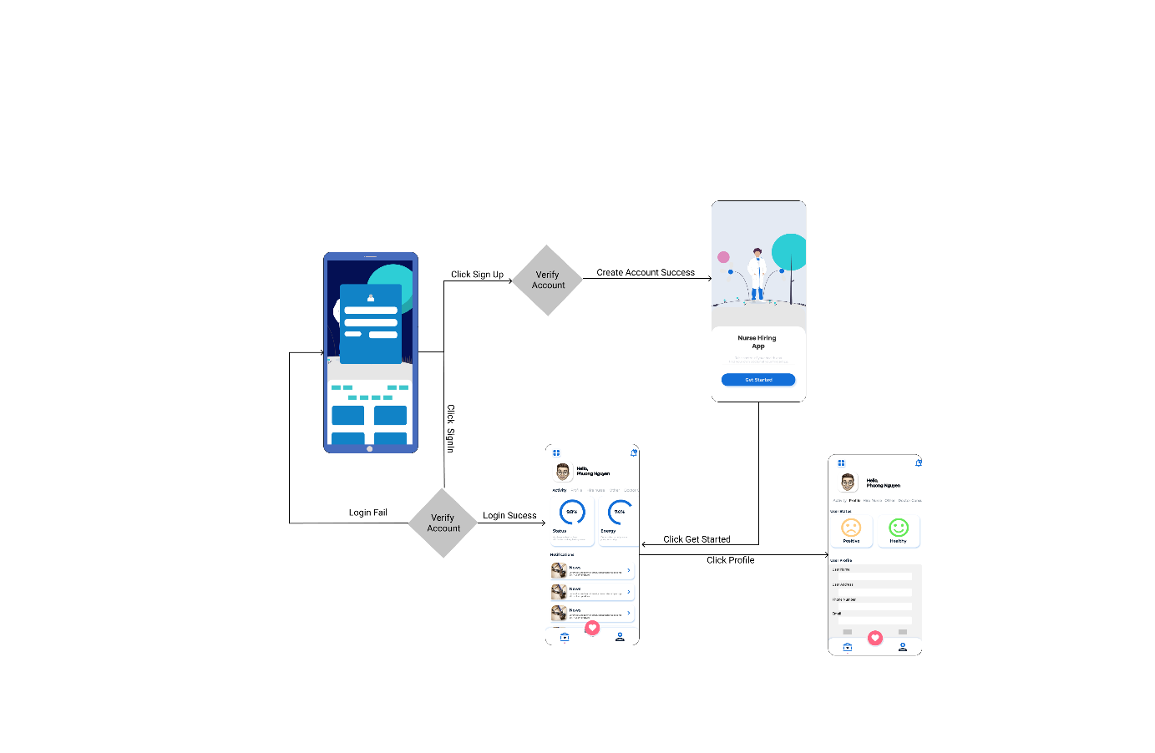

#### 3.2.7. Profile Nurse Prototype - DatHM

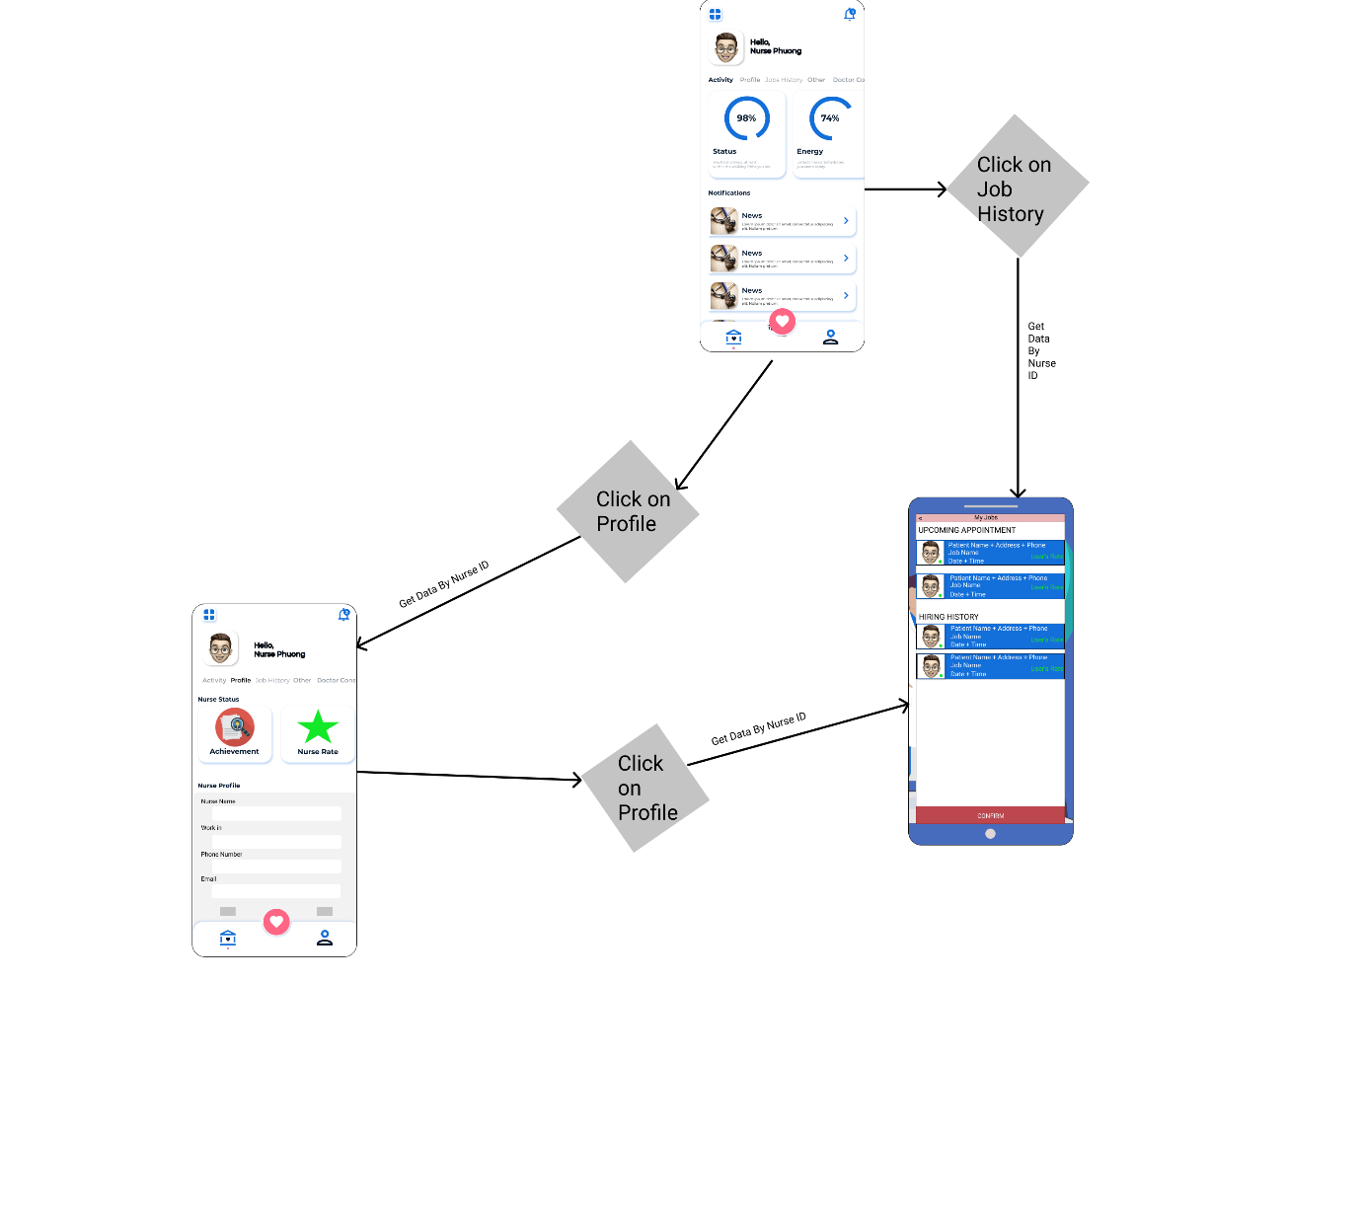

#### 3.2.8. Management Prototype - DatHM

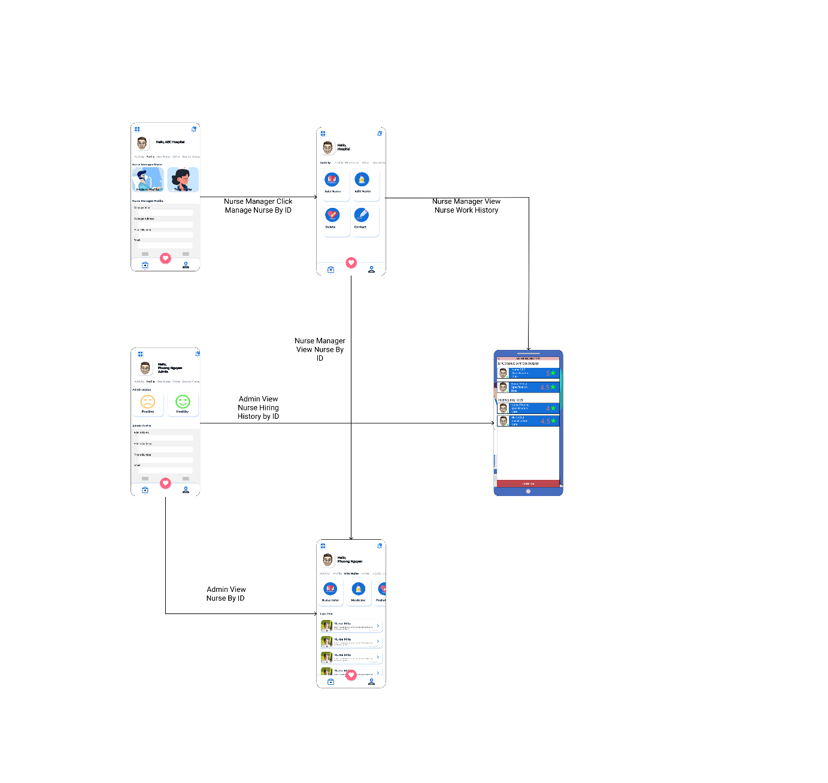

#### 3.2.9. View History Nurse Prototype - ChienDC

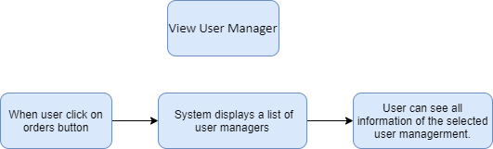

#### 3.2.10. View User Manager Info - ChienDC

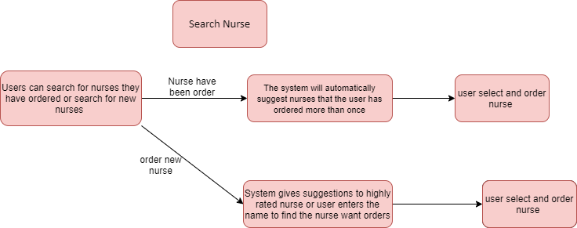

#### 3.2.11. User Search Nurse - TrungNH

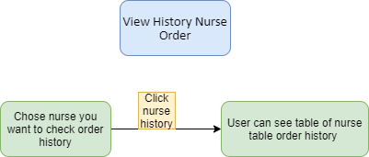

#### 3.2.12. User Paid Money for System Application – TrungNH

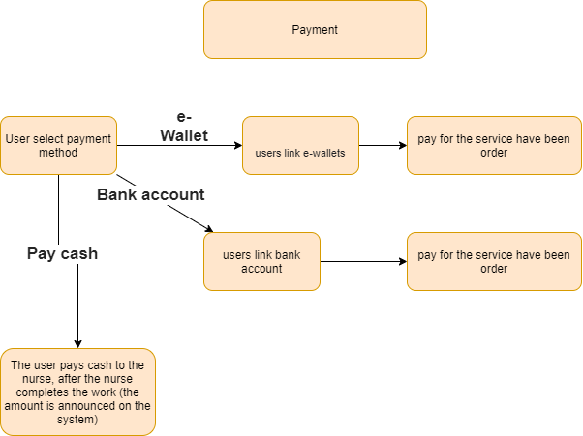

### 3.3. Prioritization

|  |  |  |  |  |  |  |  |  |  |
| --- | --- | --- | --- | --- | --- | --- | --- | --- | --- |
| *Relative Weights* | *2* | *1* |  |  | *1* |  | *0.5* |  |  |
| ***Feature*** | ***Benefit*** | ***Penalty*** | ***Total Value*** | ***Value %*** | ***Cost*** | ***Cost %*** | ***Risk*** | ***Risk %*** | ***Priority*** |
| ***1.Order nurse*** | ***8*** | ***4*** | ***19*** | ***17%*** | ***2*** | ***10%*** | ***1*** | ***10%*** | ***1.13*** |
| ***2.Select nurse between medical center and hospital*** | ***5*** | ***2*** | ***14*** | ***13%*** | ***3*** | ***16%*** | ***2*** | ***20%*** | ***0.5*** |
| ***3.Create service subscription*** | ***4*** | ***2*** | ***10*** | ***9%*** | ***2*** | ***10%*** | ***1*** | ***10%*** | ***0.6*** |
| ***4.Order service of health*** | ***4*** | ***4*** | ***12*** | ***11%*** | ***1*** | ***5%*** | ***1*** | ***10%*** | ***1.1*** |
| ***5.Order medical equipment in system condition*** | ***7*** | ***4*** | ***18*** | ***16%*** | ***3*** | ***16%*** | ***1*** | ***10%*** | ***0.76*** |
| ***6.View service subscription*** | ***3*** | ***2*** | ***8*** | ***7%*** | ***2*** | ***10%*** | ***1*** | ***10%*** | ***0.46*** |
| ***7.Modify service subscription*** | ***3*** | ***2*** | ***8*** | ***7%*** | ***2*** | ***10%*** | ***1*** | ***10%*** | ***0.46*** |
| ***8.Delete service subscription*** | ***3*** | ***2*** | ***8*** | ***7%*** | ***2*** | ***10%*** | ***1*** | ***10%*** | ***0.46*** |
| ***9.Show information of nurse*** | ***5*** | ***3*** | ***13*** | ***12%*** | ***2*** | ***10%*** | ***1*** | ***10%*** | ***0.8*** |
| ***Total*** | ***42*** | ***25*** | ***109*** | ***100%*** | ***19*** | ***100%*** | ***10*** | ***100%*** |  |

## 4. Non-Functional Requirements

### 4.1 Quality Attributes

#### a. Usability

The system can be easy to use, the system will provide the best conditions for users to perform tasks, the function of the website safely, efficiently. User gets nurse and hiring with high-quality service.

#### b. Reliability

* Availability: The system can work stable in almost time when user access. About 70% of user satisfied with nurse order and quality of service, only admin has permission to maintain the website.
* Mean Time Between Failures (MTBF): About 3-5 minutes.
* Mean Time to Repair (MTTR): About 30-60 minutes.
* Accuracy: About 80%.
* Maximum Bugs or Defect Rate: About 5%
* Bugs or Defect Rate: About 5%

#### c. Performance

For better performance, the application will allow a maximum of 50 user access at the times, and a stable network.

#### d. Dependability

Depend on a local server, depend to copy right issue and policy terms of service.

#### e. Supportability

Modifiability is minimal, might allow the user to edit data in the database but not allow to edit code.

#### f. Design Constraints

This section we using to design the website was photoshop, figma, to code we using Visual Studio 12 with C#, .Net Core, NodeJS, ReactJS, HTML, CSS, JS, API.

#### g. Support Documents

Using a Facebook plugin to make Facebook comments.

Using facebook api, google api allows user login.

Using c#, NodeJS, ReactJS tutorial docs, bootstraps, and other heal care support websites.

#### h. Purchased Components

None

### 4.2 Non-Function Requirements Planguage

#### 4.2.1. Security - HaiLD

* **TAG**: Access Authorization – Make user account data safety
* **AMBITION**: Make user data and system data safety
* **SCALE**:
* When user SignIN or SignUP, it took 1 minutes to check user data input and sent access token (IF NEED) to 3rd like Google or Facebook API. After all, bring user to Start Layout.
* Passwords user have to encode to Bcrypt hashcode.
* All inportant information have to encode to 1024bit SSL.
* When user paid, system does not have permission to save user credit/debit cards information.
* **METER**:
* Measured from the Sign IN to get user access token or Sign IN/ Log IN history to check user information. After that sent messages to user force user modified information once per month.
* **GOAL:**
* Encode important information and System must not save user credit/debit cards information.
* **STRETCH:**
* System must not save user credit/debit cards information.
* **WISH:**
* User infor must be security and safety with all **Goal** provide, tranferred between clients and servers.

#### 4.2.2. Performance – PhuongNL

* **TAG:** The software must support at least 50 users.
* **AMBITION:** System support access ability to allow users to send multiple requests at the same time to the system
* **SCALE:** Number of concurrent users
* **METER**: Concurrent users logged in, authenticated for the using system function while maintaining a login.
* **GOAL**: Support at least 50 users at the same time.
* **STRETCH**: Support at least 30 users at the same time.
* **WISH**: Support 100 users at the same time

#### 4.2.3. Usability - DatHM

* **TAG**: System UI/UX suitable with end user.
* **AMBITION**: Make system become easier for user.
* **SCALE**: Depends on number of clear function and interface designs.
* **METER**: Depend on users, such as customers or e-commerce sites, or employees with an intranet (in other cases, they must be people who don't work with this project).
* **GOAL**: Support for user to using application convenient
* **STRETCH**: Over 65% of users using the application systems.
* **WISH**: Over 90% of users satisfied with UI/UX app system.

#### 4.2.4. Maintainability & Extensibility - ChienDC

* **TAG**: Apply to React Native and PHP architecture for the application system.
* **AMBITION**: Make system become easy to maintain by using open-sourse language to maintain server.
* **SCALE**: Depends on system design, model of system, process model development.
* **METER**: System needs to be maintained 2 time each year, extensibility when system become old with another system.
* **GOAL**: Maintainers easy maintain project, servers. (10 times/ year)
* **STRETCH**: Maintain 5 times per year.
* **WISH**: Maintain 2 times per year.

#### 4.2.5. Availability - TrungNH

* TAG: Application ready to use and nurse always ready to hire
* AMBITION: Support user and allow user to hire nurse anytime.
* SCALE: Depends on Hospital and Health Center and Nurse Ability.
* METER: Sytem already has 2 or 3 nurses to hire.
* GOAL: Allow user to hires as more nurse as they can
* STRETCH: Allow user to hires 2 nurses once they place order.
* WISH: System should connect with more hospitals to hire nurses as more as user order.

## 5. Swinlane Diagram

### 5.1. User Payment

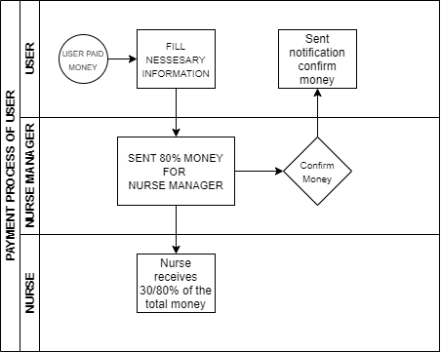

**Fig. 6. User Payment Swinlane**

### 5.2. User Order

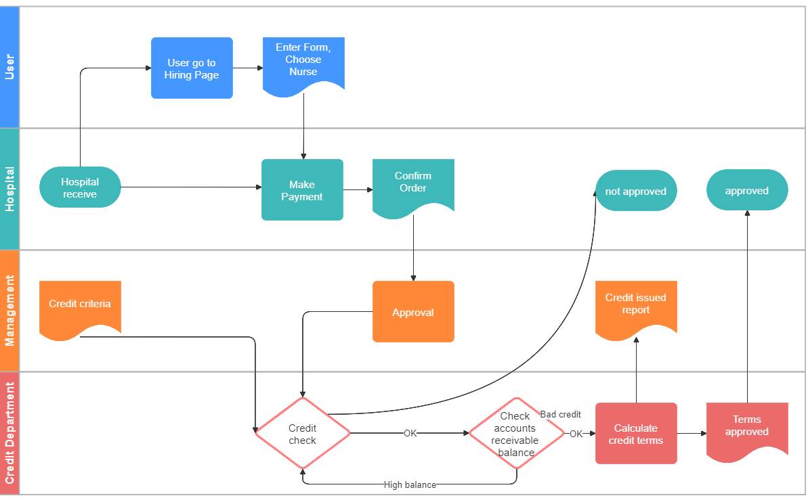

**Fig. 7. User Order Swimlane**